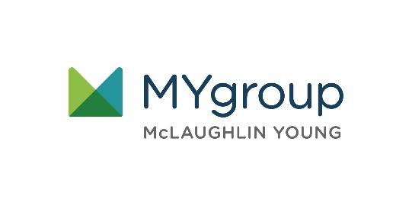

LET US HELP

TOLL-FREE: 800-633-3353

WEBSITE: [www.mygroup.com](http://www.mygroup.com) > My Portal Login > Work-Life

USERNAME: organization specific

PASSWORD: guest

**YOUR EMPLOYEE ASSISTANCE PROGRAM**

**APRIL 2021**

Always Available | Free | Confidential

Financial Security

Being comfortable with   
your finances

No matter where you are in your financial journey, we can help you take proactive steps to improve. Call us to get started today.

**APRIL 2021**