

Visit your home page starting April 20th

WEBSITE: [www.mygroup.com](http://www.mygroup.com) > My Portal Login > Work-Life

USERNAME: organization specific

PASSWORD: guest

LET US HELP

**YOUR EMPLOYEE**

**ASSISTANCE PROGRAM**

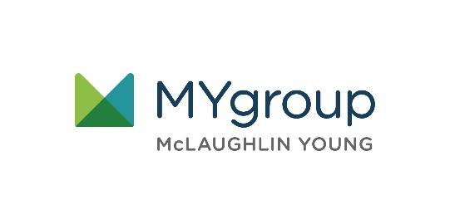

**APRIL 2021**

The Steps to Financial Security

ONLINE SEMINAR

Feel secure about   
your finances

Understand the practical ways you can feel more secure and more stable with your finance management.

Always Available | Free | Confidential

**APRIL 2021**