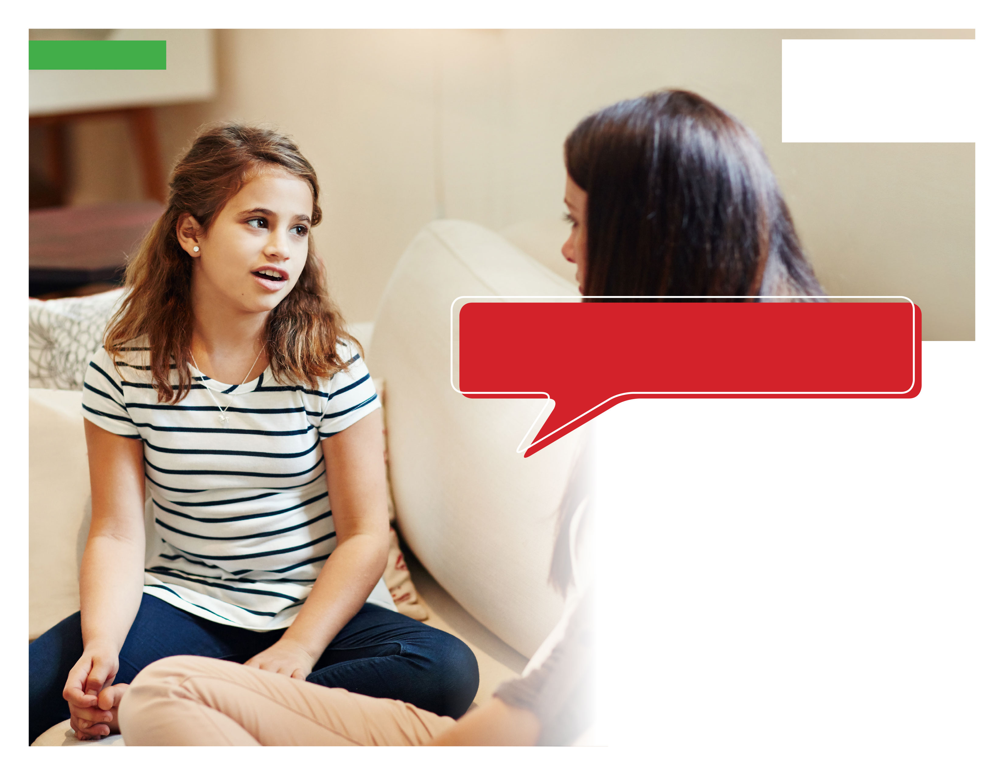

Your Employee Assistance Program is there 24/7 with   
information and resources to help you work better, together.

**Visit your home page starting April 21st**

**TOLL-FREE: 800-633-3353**

**WEBSITE:** [**www.mygroup.com**](http://www.mygroup.com) **> My Portal Login > Work-Life**

**USERNAME: organization specific**

**PASSWORD: guest**

**WHATEVER YOU NEED, WE ARE HERE TO HELP.***Just call or log on to get started.*

**ONLINE SEMINAR**

Tune in to this session to learn about different communication styles and how to communicate effectively, starting in   
early childhood.

**Effective Communication   
with Children**



**APRIL 2020**