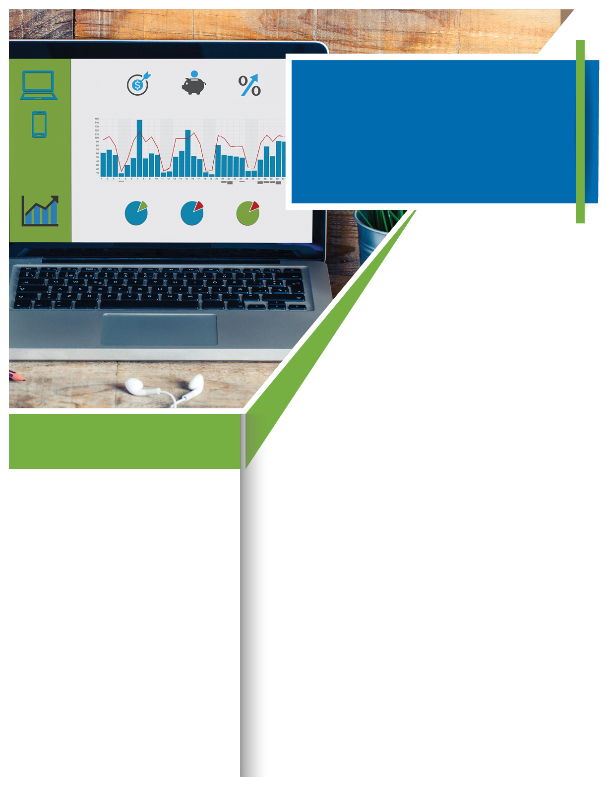­­

Available any time, any day, your Employee Assistance Program is a free, confidential benefit to help you balance your work, family, and personal life.

TOLL-FREE:

**800-633-3353**

WEBSITE:

[**www.mygroup.com.com**](http://www.mygroup.com.com) **> My Portal Login > Work-Life**

USERNAME:

**Organization specific**

PASSWORD:

**guest**

A big vacation. A child’s tuition. A comfortable retirement. It’s easy to envision the future we want, but harder to create a plan to achieve it. Fortunately, your Employee Assistance Program provides a range of financial resources, such as:

- Creating (and sticking to!) a budget.

- Creating an emergency fund.

- Building better credit.

- Buying a home.

- Information on planning for retirement.

Today is the best day to begin planning your future and to make those changes you’ve been thinking about.

**Take ownership of your finances.**

**A Plan for the Future**



**YOUR** EMPLOYEE **ASSISTANCE** PROGRAM

August

***Just call or log on to get started.***

**WHATEVER YOU NEED,**

**WE ARE HERE TO HELP.**