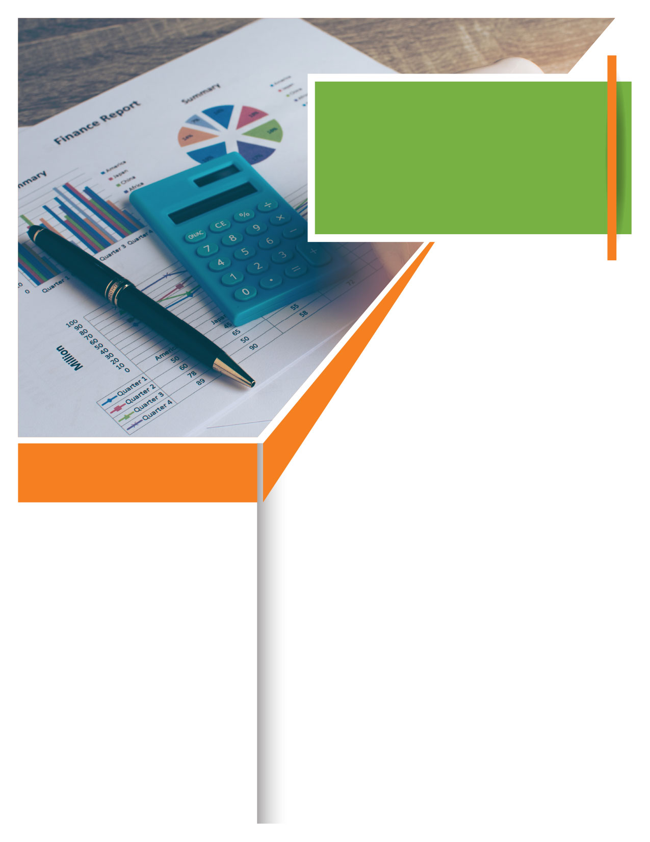

TOLL-FREE:

**800-633-3353**

WEBSITE:

[**www.mygroup.com**](http://www.mygroup.com) **> My Portal Login > Work-Life**

USERNAME:

**Organization specific**

PASSWORD:

**guest**

Your Employee Assistance Program, available 24/7 to

Learn more about these financial achievements with resources provided.

This session will guide you through the process of tracking your spending so that you understand how you currently spend money.

Examine your obstacles to reaching your   
financial goals, learn how to manage your debt, and develop a personal debt reduction plan. Budgeting is an important life skill, whether you need to pay down a debt, save for a future purchase, or put money into investments.

**ONLINE SEMINAR**

**WHATEVER YOU NEED,**

**WE ARE HERE TO HELP.**

***Just call or log on to get started.***

**Visit your home page starting August 20th:**

**Effective Budgeting**



August