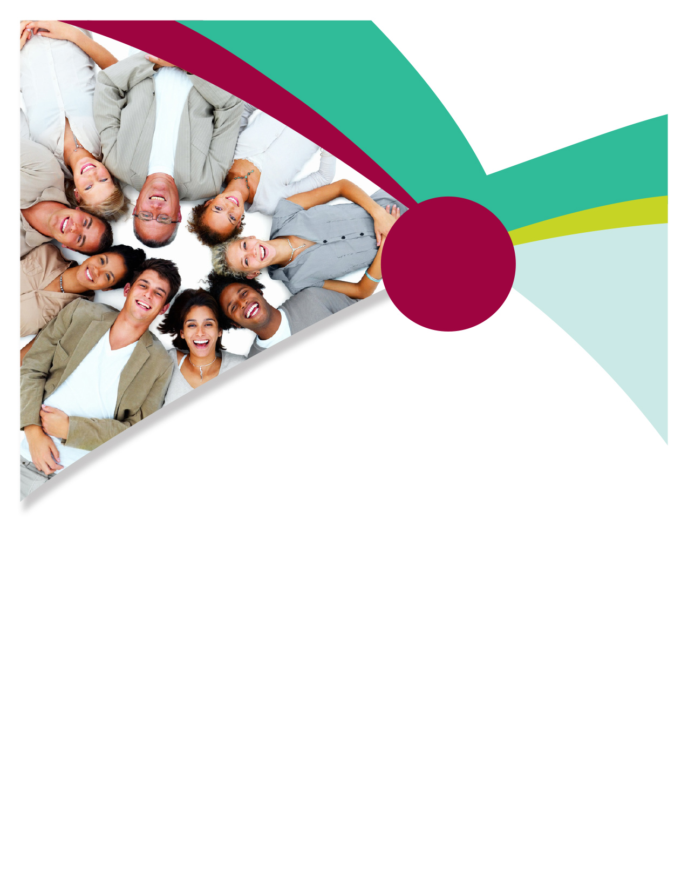

A multicultural workplace brings together a variety   
of ethnicities, races, religions, genders, and abilities.   
Organizations that address the challenges and embrace   
the positive impacts of multiculturalism are more likely to succeed and grow. By taking advantage of the wide variety   
of viewpoints that multiculturalism provides, organizations   
make room for more thoughtful decision making, innovation,   
and creative thought. Your Employee Assistance Program can provide guidance, information, and resources to help you embrace the multicultural workplace.

**ONLINE SEMINAR**

**Diversity in the Workplace:   
Maintaining an Inclusive Environment**

Each member of the workforce brings unique skills, background,   
and experience vital to the successful organizations. A diverse   
workforce is a rich source of creativity and problem-solving.

**Available on Demand Starting December 19th**

Online seminars can be found on your home page,

or you can search for them by title.

TOLL-FREE: **800-633-3353**

WEBSITE: **www.mygroup.com**

Username: **organization specific**

Password: **organization specific**

Available anytime, any day, your Employee Assistance Program is a free, confidential program to help you balance your work, family, and personal life.

EMPLOYEE Assistance PROGRAM **DEC. 2017**

Embracing a multicultural workplace

FUSION

FORWARD

