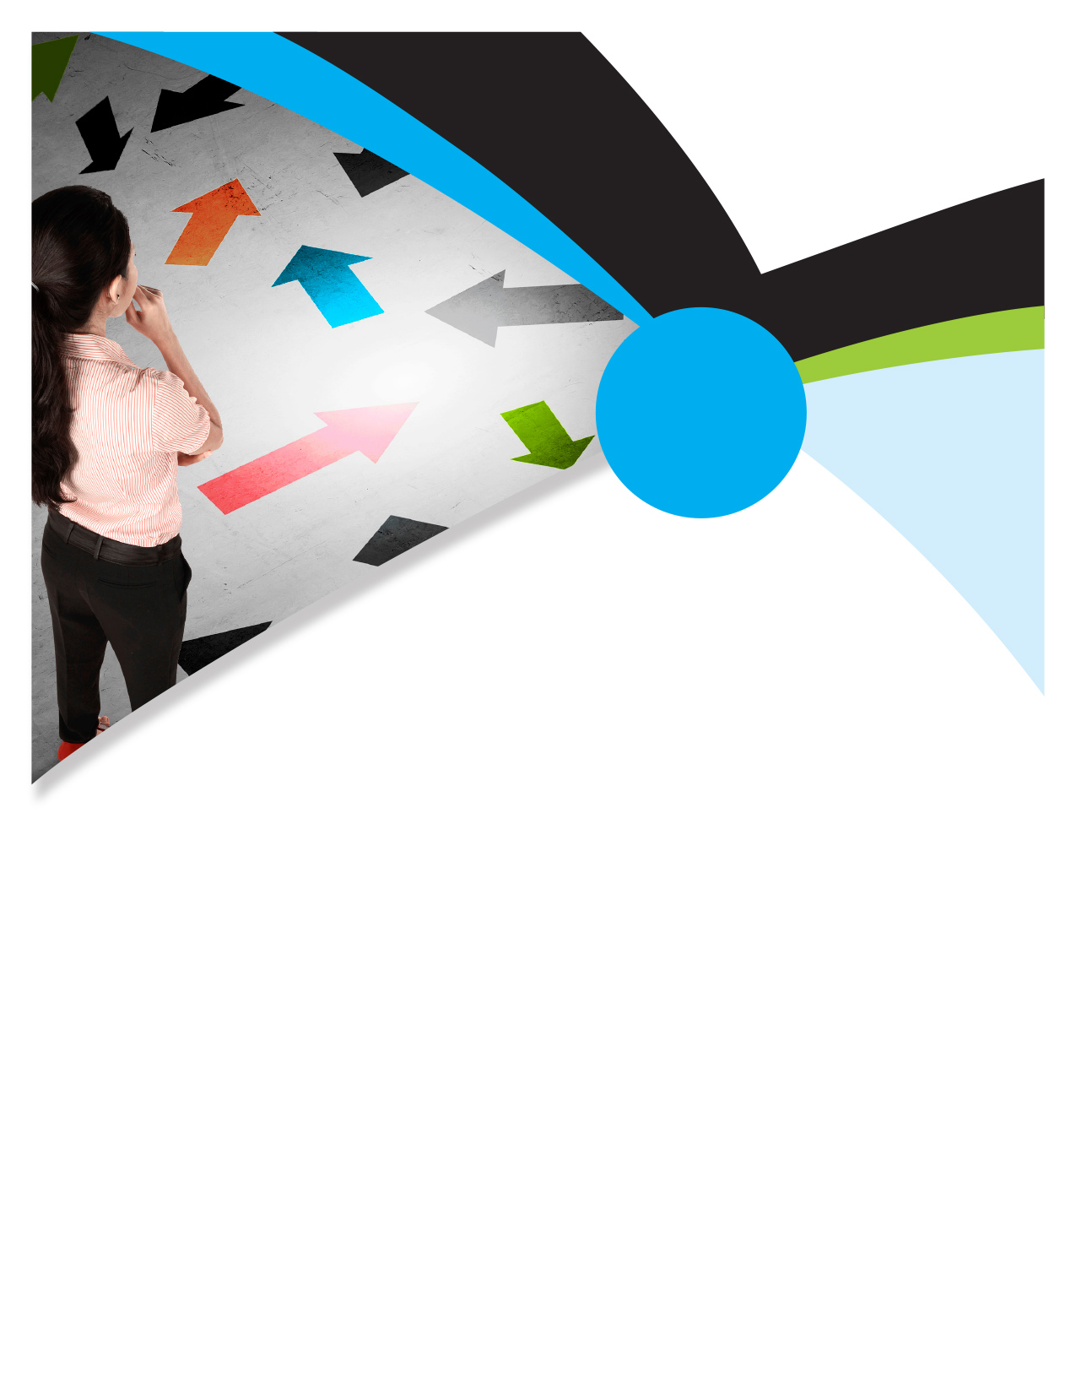

EMPLOYEE **Assistance**PROGRAM **2020**

Keep Calm and Carry On

Maintaining Your Composure Amidst the Pandemic Panic

**The session will cover:**

* Strategies to tackle feelings of anxiety and stress
* Practical techniques for working from home
* Ways to address signs of panic in the workplace
* When to reach out for further help and support

The coronavirus has led to widespread fear on a global scale. The pervasive impact of the outbreak on a humanitarian and economical scale means that levels of extreme uncertainty and anxiety is rife and unprecedented business and health challenges are being presented across the world. Whilst every person and every business strives to adapt to the situation and discover ways to continue whilst still mitigating the risks presented, societal stress levels remain high and the viral outbreak poses a very real threat to the wellbeing of our communities, from both a psychological and physical perspective. Given that stress has an adverse impact on our immune system, it is more important than ever to retain a healthy sense of perspective, focus upon practical ways to adapt to the situation and respond in a composed way to the outbreak.

**ONLINE SEMINAR**

**Available on Demand Starting March 21st**

Online seminars can be found on in your Work-Life portal.

TOLL-FREE: **800-633-3353**

WEBSITE: [**www.mygroup.com**](http://www.mygroup.com) **> My Portal Login > Work-Life >**

Username: **Organization Specific** Password: **guest > Online Seminars**

Available anytime, any day, your Employee Assistance Program is a free, confidential program to help you balance your work, family, and personal life.

