

**YOUR EMPLOYEE**

**ASSISTANCE PROGRAM**

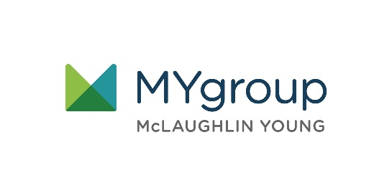

**FEBRUARY 2021**

Visit your home page starting February 16th

WEBSITE: [www.mygroup.com](http://www.mygroup.com) > My Portal Login > Work-Life

USERNAME: organization specific

PASSWORD: guest

LET US HELP

Setting Goals for Your Future

ONLINE SEMINAR

Success starts by setting smart goals

Learn how to strategically set short-term and long-term goals to help you succeed in all areas of your life.

Always Available | Free | Confidential

**FEBRUARY 2021**