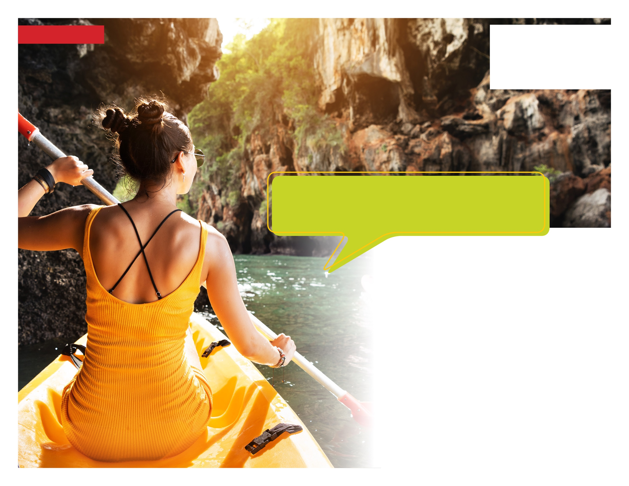

**New challenges inspire self-growth**

Ready for a thrill? Perhaps exploring a distant place or tackling a new challenge? You should: Adventures can boost our self-confidence, problem-solving, and creativity.

We can help you brainstorm travel ideas and even help arrange transportation. If you prefer to stay closer to home, we can connect you with social groups and local getaways. Begin your next adventure today!

**Embrace Adventure**

**WHATEVER YOU NEED, WE ARE HERE TO HELP.***Just call or log on to get started.*

**TOLL-FREE: 800-633-3353**

**WEBSITE: mygroup.com > My Portal Login > Work-Life**

**USERNAME: organization specific**

**PASSWORD: guest**

**YOUR EMPLOYEE ASSISTANCE PROGRAM**

Available any time, any day, your Employee Assistance Program is a free, confidential benefit to help you balance your work, family, and personal life.

**JULY 2020**

