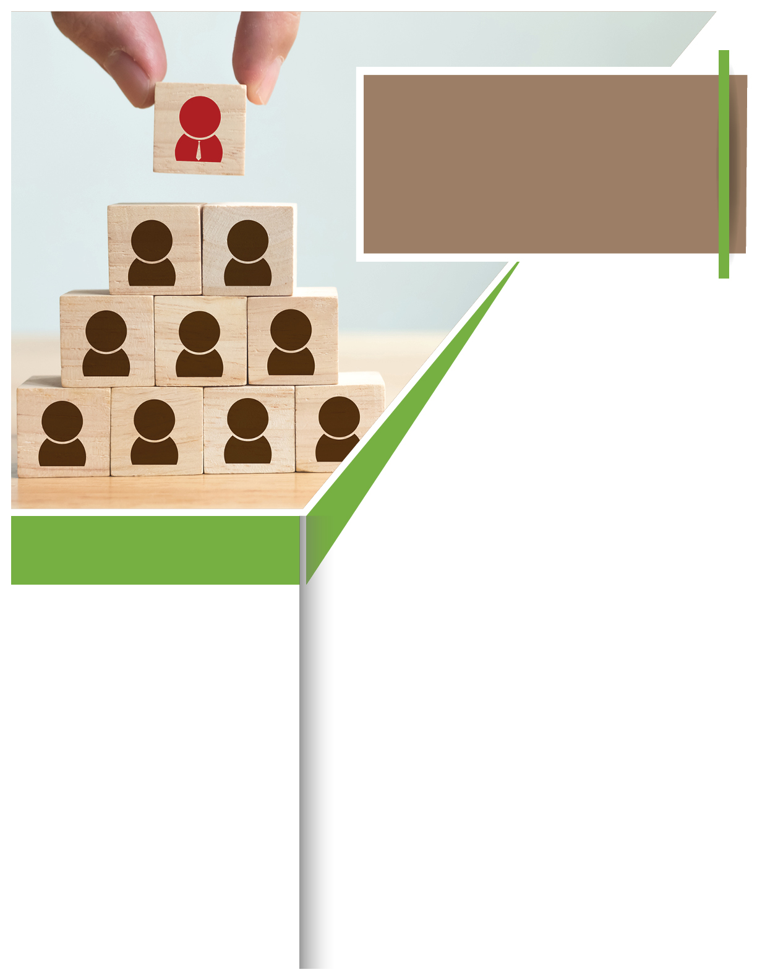­­



It’s the team we want: coworkers who feel valued, show mutual respect, and share helpful feedback. Healthy workplace relationships not only make our work enjoyable, they make our work better. They create:

- **Strong outcomes:** When coworkers feel confident expressing views, teams make vetted decisions.

- **Full participation:** Teams that respect differences encourage all members to play active roles.

- **High productivity:** With clear communication, teams get to do the work that they do best.

If you’re looking to build better workplace relationships, your Employee Assistance Program can help. Professional counseling, resources, information, and referrals can help you improve communication strategies, de-escalation techniques, and other interpersonal skills that improve workplace relationships.

TOLL-FREE: **800-633-3353**

WEBSITE:

[**www.mygroup.com**](http://www.mygroup.com) **> My Portal Login > Work-Life**

USERNAME:**company specific**

PASSWORD:**guest**

Available any time, any day, your Employee Assistance Program is a free, confidential benefit to help you balance your work, family, and personal life.

**Work Together. Better.**

**Enhance your team – and career – with strong relationships.**

**YOUR** EMPLOYEE **ASSISTANCE** PROGRAM

January

***Just call or log on to get started.***

**WHATEVER YOU NEED,**

**WE ARE HERE TO HELP.**