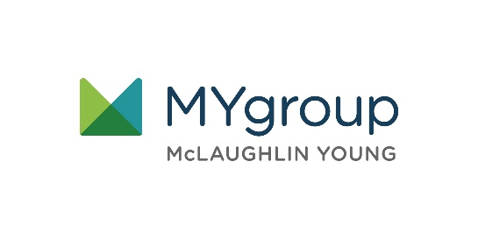

**YOUR EMPLOYEE**

**ASSISTANCE PROGRAM**

LET US HELP

TOLL-FREE: 800-633-3353

WEBSITE: mygroup.com > My Portal Login > Work-Life

USERNAME: organization specific

PASSWORD: guest

Always Available | Free | Confidential

**JANUARY 2021**

**JANUARY 2021**

Positive Reframing

Stepping into the new year, realistically

We can help you think about things realistically and from a point of optimism. Be present in the moment, and reframe your year.