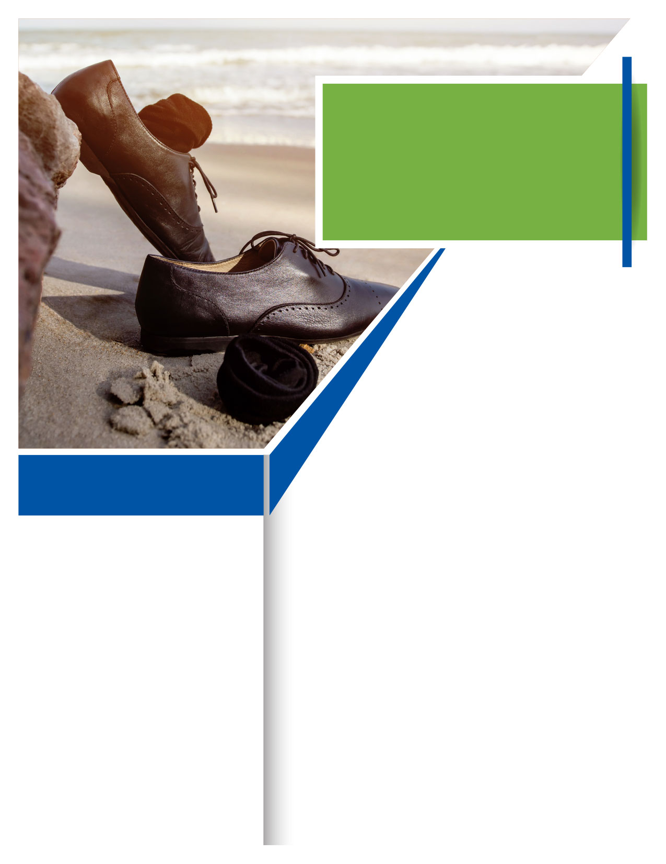

Your Employee Assistance Program help you achieve balance today, available 24/7.

The conflicting demands of work and home can create stress and zap the time and energy needed to get everything done. Balancing what needs to be done in an effective manner can lead to more satisfaction with both home and work lives, personal and professional.

**ONLINE SEMINAR**

This session will help participants identify various ways to achieve balance with personal, family and work responsibilities.

**Making a Life While Making a Living: Work-Life Balance**



July

**WHATEVER YOU NEED,**

**WE ARE HERE TO HELP.**

***Just call or log on to get started.***

TOLL-FREE:

**800-633-3353**

WEBSITE:

**www.mygroup.com**

USERNAME:

**Organization specific**

PASSWORD:

**guest**

**Visit your home page starting July 16th:**