

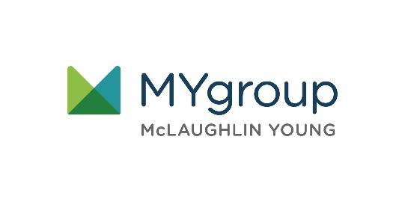

Visit your home page starting July 20th

WEBSITE: [www.mygroup.com](http://www.mygroup.com) > My Portal Login > Work-Life

USERNAME: college specific

PASSWORD: guest

LET US HELP

**YOUR STUDENT**

**ASSISTANCE PROGRAM**

Maximizing Your Summer Break

ONLINE SEMINAR

Have fun and be creative

Learn straightforward and effective ways to make the most of your holiday and maximize the moments and memories.

**JULY 2021**

Always Available | Free | Confidential

**JULY 2021**