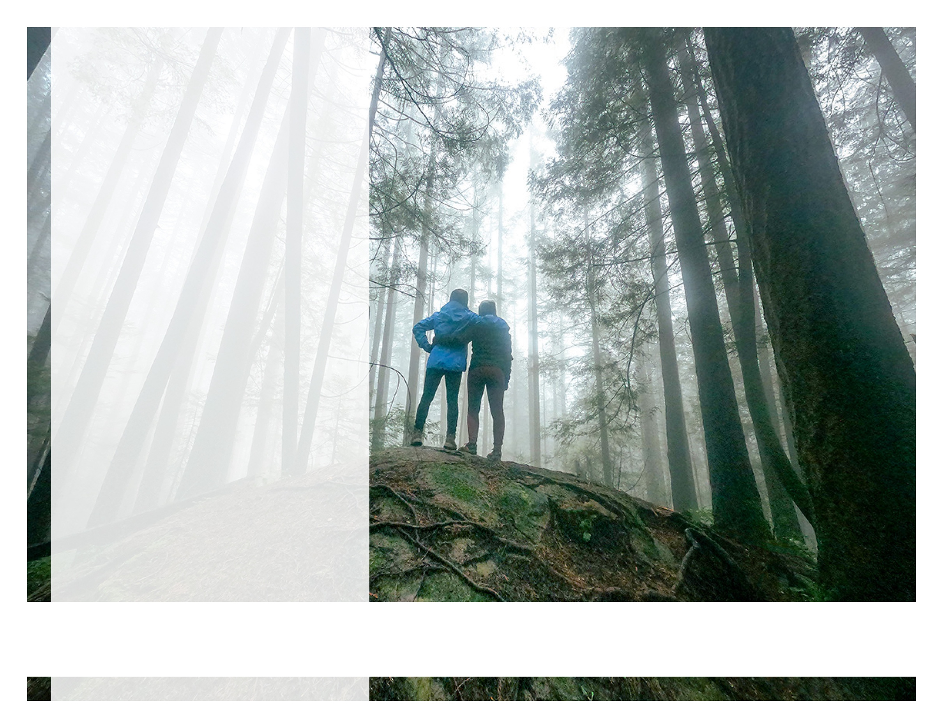

Finding Yourself Through Nature

ONLINE SEMINAR

Taking the path less traveled

Discover the importance of being outside and find your own way to enjoy nature, and increase your wellbeing.

JUNE 2022

LET US HELP

Visit your home page starting June 21st

WEBSITE: [www.mygroup.com](http://www.mygroup.com) >

My Portal Login > Work-Life

USERNAME: organization specific

PASSWORD: guest

Always Available | Free | Confidential

YOUR MEMBER ASSISTANCE PROGRAM