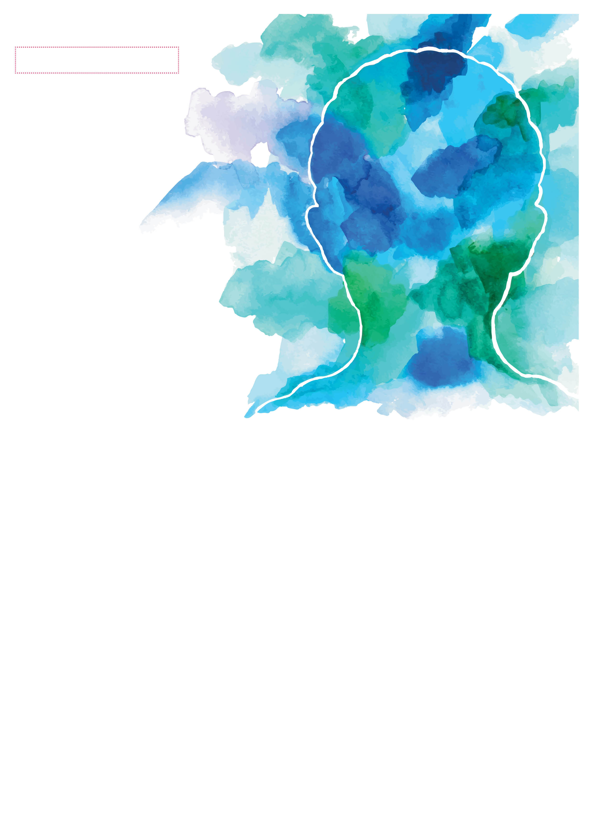

**World**

October 10TH is

World Mental Health Day is held annually on October 10th and is an opportunity for all of us to raise awareness, advocate against stigma, and take steps to support better mental health for one and all.

This year, we want to provide the tools and techniques to help individuals take a positive   
and active approach to prioritizing their own mental wellbeing.

***Building Better Mental Health  
Recorded Webinar:***

The ***Building Better Mental Health*** webinar is pre-recorded and will be released to your Employee Assistance Program website on Friday, October 9th. The webinar will be available for quite some time after, so you can choose a time and day to view that works best for you.

**This session will include:**

* Learn about the importance of managing your mental health
* Understand the impact of self-stigma
* Discover ways to combat negative thoughts
* Explore practical ways to optimize levels of mental wellbeing
* Consider ways to utilize the resources and support available
* Develop a plan for positive change

*Disclaimer: the free webinar is only presented in English*

**YOUR EMPLOYEE   
ASSISTANCE PROGRAM**

Anytime, any day, you have free, confidential access to professional consultants and online resources to help you be your best.   
Just call or log on to get started.

TOLL-FREE:   
**800-633-3353**

WEBSITE:  
[**www.mygroup.com**](http://www.mygroup.com) **> My Portal Login > Work-Life**

USERNAME:   
**organization specific**

PASSWORD:   
**guest**

**MENTAL**

**HEALTH DAY**

