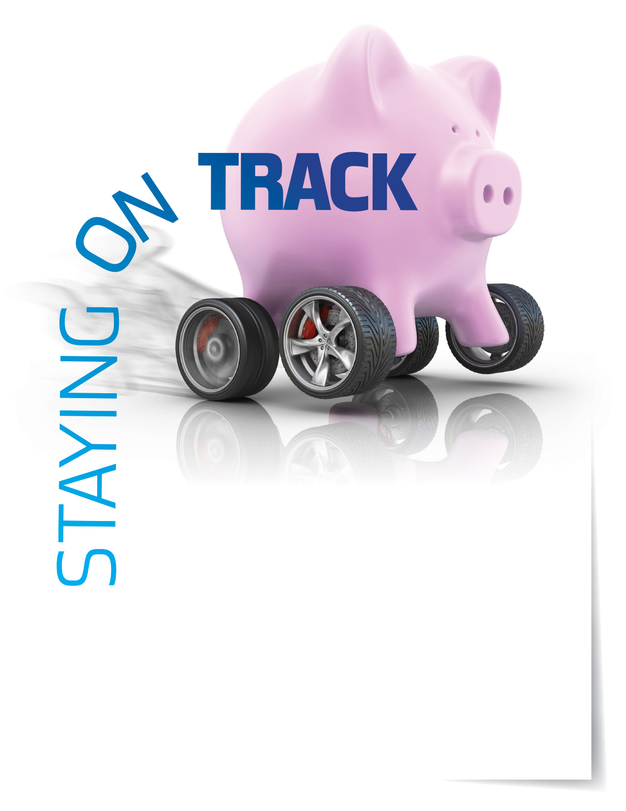

**Budgeting and personal finances**

Learn ways to keep track of your spending and live within   
a budget. Start saving for short- and long-term goals.

Your Employee Assistance Program can help with:

* Articles on credit card debt, saving for retirement, and more
* Downloadable monthly budget form
* Financial calculators on investments, home finance,   
  saving, and more
* Personal Financial Information Organizer

**CALL OR VISIT US ONLINE**

TOLL-FREE: **800-633-3353**

**www.mygroup.com**

USERNAME: **organization specific**

PASSWORD: **guest**

Available anytime, any day, your Employee Assistance   
Program is a free, confidential program to help   
you balance your work, family, and personal life.



EMPLOYEE **Assistance** PROGRAM

**MAR. 2018**