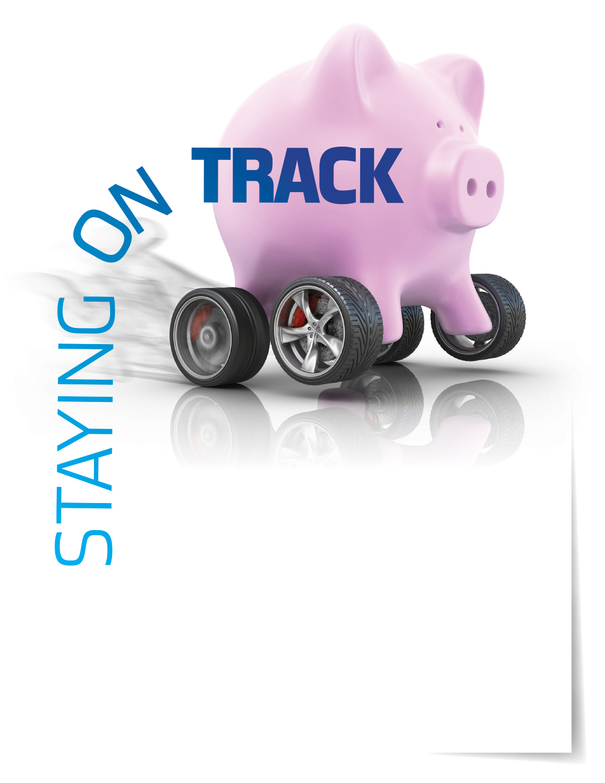

Budgeting and personal finances

Budgeting can help you plan for short-term goals like dinner at a nice restaurant

or longer-term ones like a vacation or buying a home. The best feature of any

budget is the peace of mind it can provide you. Your Employee Assistance Program is available 24/7 with information on budgeting and ways to stay on track.

**ONLINE SEMINAR**

Your Routine Financial Check-up

Examine your finances from a variety of   
perspectives, and review and prioritize all   
of your debts as you explore your assets.

**Visit your home page starting Mar. 20th:**

**www.mygroup.com**

USERNAME: **organization specific**

PASSWORD: **guest**

TOLL-FREE: **800-633-3353**

Available anytime, any day, your Employee Assistance   
Program is a free, confidential program to help   
you balance your work, family, and personal life.



EMPLOYEE **Assistance**

PROGRAM

**MAR. 2018**