

Visit your home page starting May 18th

WEBSITE: [www.mygroup.com](http://www.mygroup.com) > My Portal Login > Work-Life

USERNAME: organization specific

PASSWORD: guest

LET US HELP

**YOUR EMPLOYEE**

**ASSISTANCE PROGRAM**

Addressing Anxiety in an Uncertain World

ONLINE SEMINAR

Recovering from stressful situations

Learn how to recognize and manage anxiety to actively combat the physical and mental effects in a practical way.

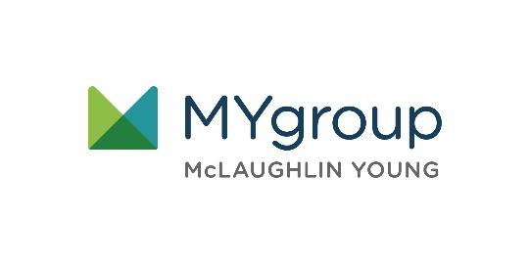

**MAY 2021**

Always Available | Free | Confidential

**MAY 2021**