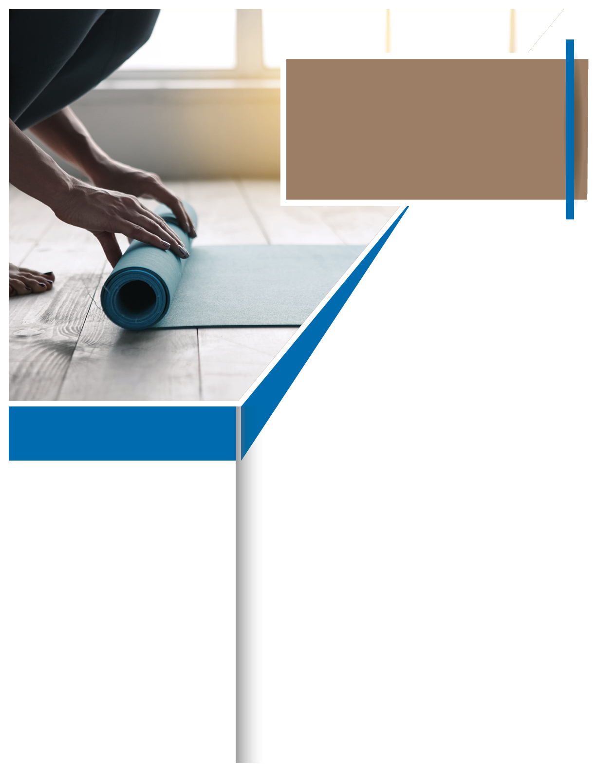­­

Available any time, any day, your Employee Assistance Program is a free, confidential benefit to help you balance your work, family, and personal life.

**YOUR** EMPLOYEE **ASSISTANCE**  PROGRAM

A healthy lifestyle creates greater energy and productivity, empowering us to do more and to do it better. Taking care of yourself is time well invested. Improve your wellbeing with small steps that easily fit into your daily schedule.

- **Find time.** Trade 15 minutes of social media for movement minutes and taking a short walk or stretch break.

- **Protect time.** Block time on your calendar for a movement break, and honor it like you would an important meeting.

- **Buddy up.** Accountability partners share goals and encouragement, and help make your wellbeing activities more successful and fun.

Call and speak to professionals who can provide counseling; referrals to local wellbeing resources; and articles, tips, and self-assessments.

**Make time for you.**

**Prioritizing Wellbeing**



TOLL-FREE:

**800-633-3353**

WEBSITE:

**www.mygroup.com**

USERNAME:

**Organization specific**

PASSWORD:

**guest**

May

***Just call or log on to get started.***

**WHATEVER YOU NEED,**

**WE ARE HERE TO HELP.**