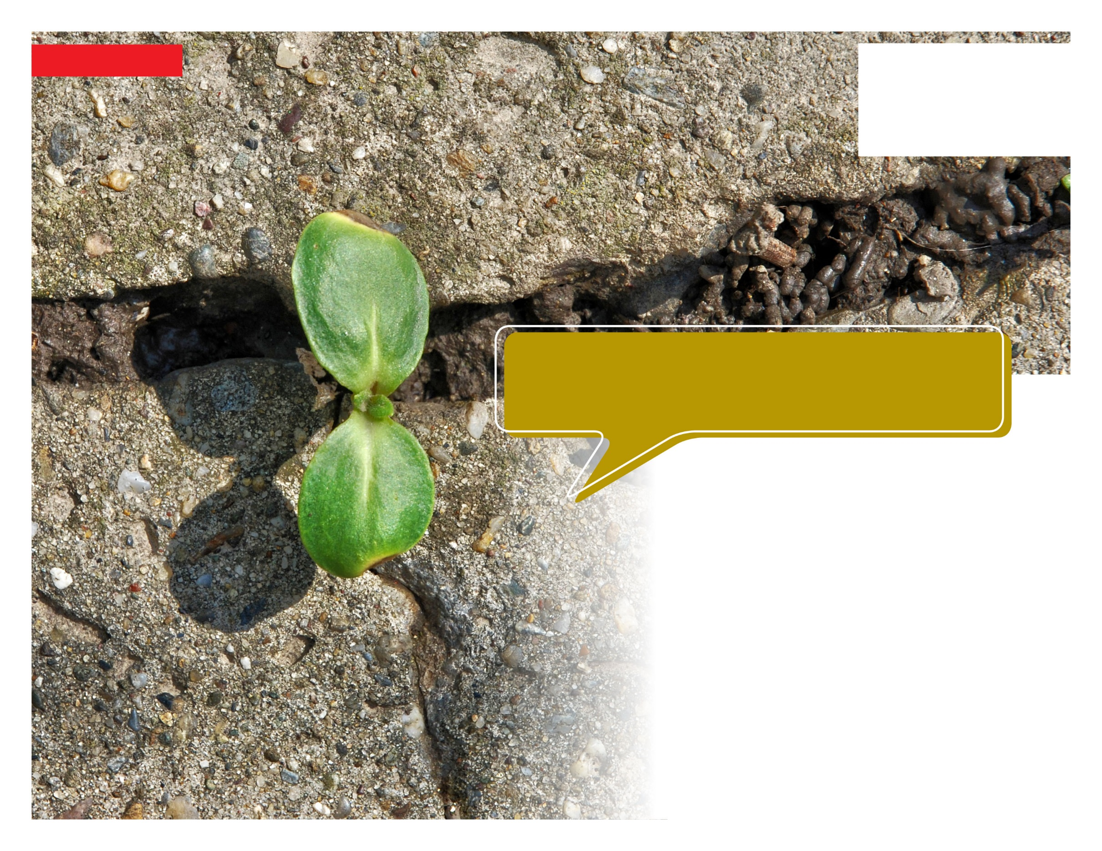

**Visit your home page starting November 17th**

**TOLL-FREE: 800-633-3353**

**WEBSITE:** [**www.mygroup.com**](http://www.mygroup.com) **> My Portal Login > Work-Life**

**USERNAME: organization specific**

**PASSWORD: guest**

**WHATEVER YOU NEED, WE ARE HERE TO HELP.***Just call or log on to get started.*

Your Employee Assistance Program is there 24/7 with   
information and resources to help you work better, together.

**Building Resilience Muscles**

**ONLINE SEMINAR**

The foundation of resilience lies in building five muscles—three are specific skills and two are personal choices that are consistently chosen. The key to resilience is understanding yourself and identifying the mental obstacles that get in your way.

**NOVEMBER 2020**

