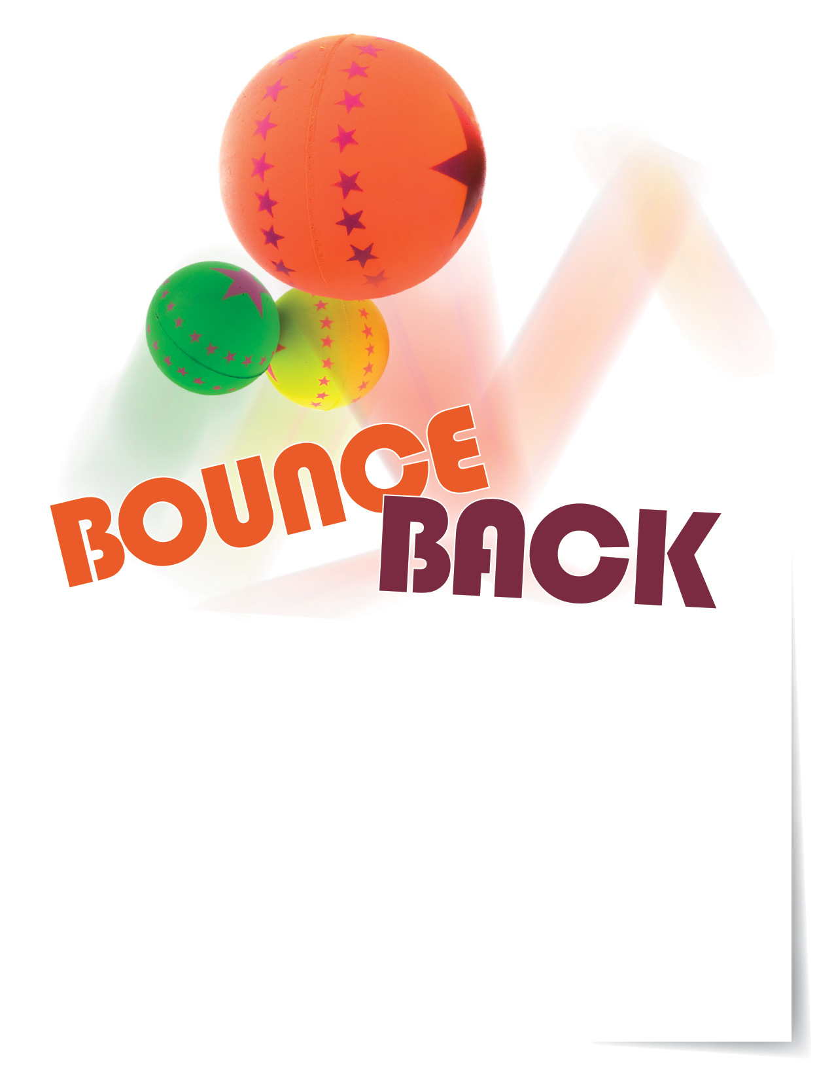

**Recovering from stressful situations**

Deadlines at work or responsibilities at home can raise our stress levels and   
lead to feelings of burnout. The ability to bounce back from that stress is called resilience. Your Employee Assistance Program is available 24/7 to help you   
strengthen your resilience and find ways to bounce back.

**ONLINE SEMINAR**

A Personal Guide to Building Resiliency and Coping with Change

It’s not what happens to us but how we respond to what is happening to us.   
This seminar will empower you to become more resilient.

**Visit your home page starting Oct. 16th:**

**www.mygroup.com**

USERNAME: **organization specific**

PASSWORD: **guest**

TOLL-FREE: **800-633-3353**

Available anytime, any day, your Employee Assistance   
Program is a free, confidential program to help   
you balance your work, family, and personal life.



EMPLOYEE **Assistance** PROGRAM

**OCT. 2018**