

Visit your home page starting June 15th

WEBSITE: [www.mygroup.com](http://www.mygroup.com) > My Portal Login > Work-Life

USERNAME: organization specific

PASSWORD: guest

LET US HELP

**YOUR EMPLOYEE**

**ASSISTANCE PROGRAM**

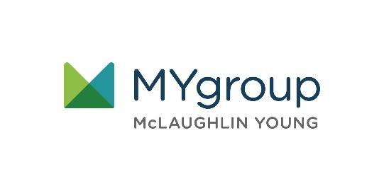

Building Healthy   
and Happy Relationships

ONLINE SEMINAR

Setting healthy boundaries

Identify the ways to build and maintain healthy relationships with those around you, with a focus on boundary setting.

**JUNE 2021**

Always Available | Free | Confidential

**JUNE 2021**