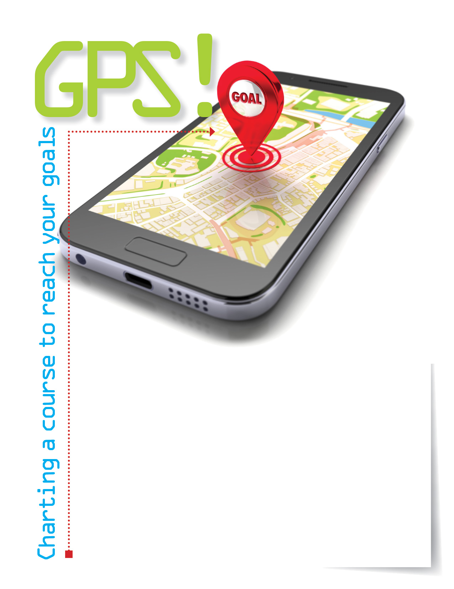



Establishing clear, attainable goals for yourself is the first step in achieving them.   
Make the positive changes you have been dreaming about by taking action.

Your Employee Assistance Program can help with:

* Articles on time management, healthy relationships,   
  and weight loss
* Audio on setting realistic goals
* Skill builder training on effective communication
* Downloadable budget forms

**CALL OR VISIT US ONLINE**

TOLL-FREE: **800-633-3353**

**www.mygroup.com**

USERNAME: **company specific**

PASSWORD: **guest**

Available anytime, any day, your Employee Assistance   
Program is a free, confidential program to help   
you balance your work, family, and personal life.

EMPLOYEE **Assistance** PROGRAM

**SEPT. 2018**