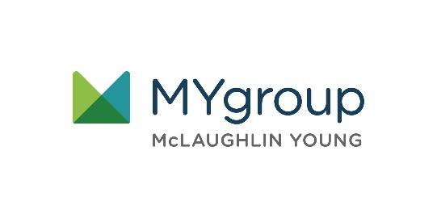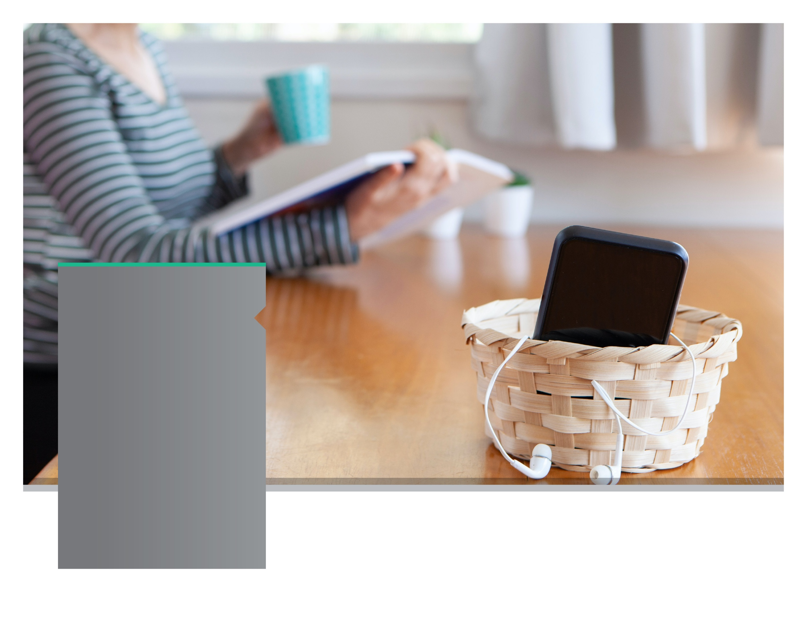

**YOUR EMPLOYEE**

**ASSISTANCE PROGRAM**

**SEPTEMBER 2021**

**SEPTEMBER 2021**

Technology Time Out

Reducing technology overload

Don't miss out by being stuck on your devices. Schedule 'no technology time', learn to be present, and learn mindfulness practices.

LET US HELP

TOLL-FREE: 800-633-3353

WEBSITE: [www.mygroup.com](http://www.mygroup.com) > My Portal Login > Work-Life

USERNAME: organization specific

PASSWORD: password

Always Available | Free | Confidential