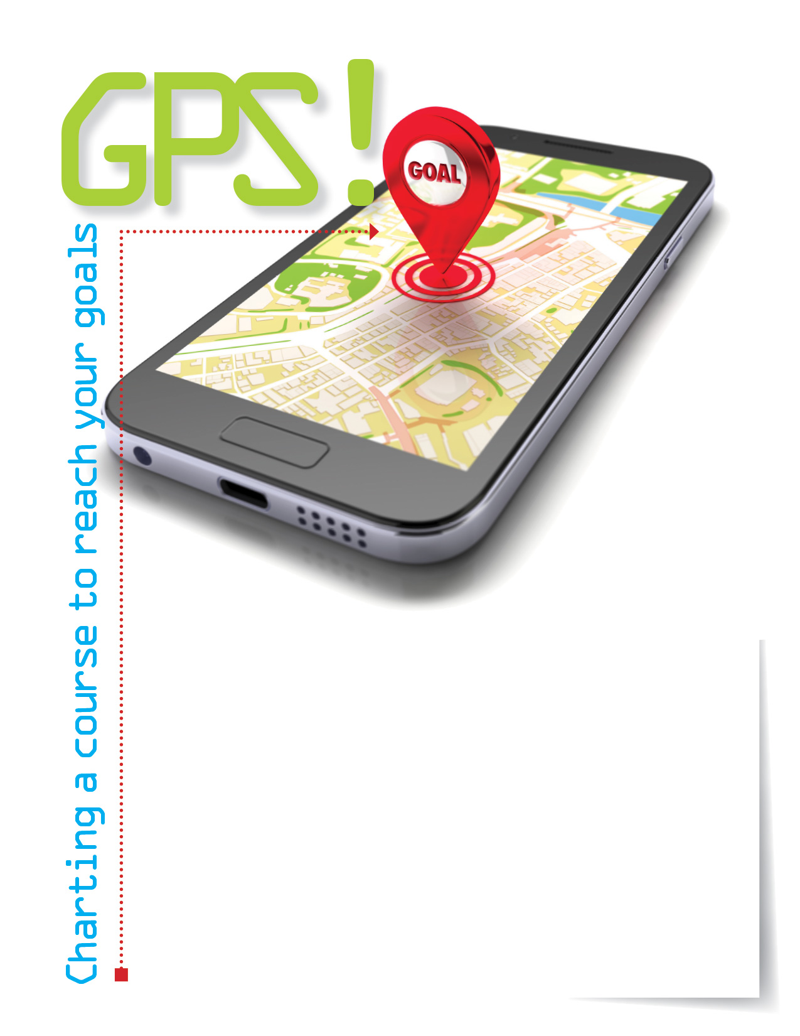

Setting goals gives you focus, a way to measure your success, and motivation to avoid getting distracted. Simple strategies like writing goals down, sharing them with others, and giving yourself a time limit will help keep you on course. Your Employee Assistance Program can help you find ways to achieve your goals.

**ONLINE SEMINAR**

Creating a Personal Development Plan

Participate in this session to understand effective goal setting and identify potential obstacles that can create barriers to reaching your goals.

**Visit your home page starting Sep. 18th:**

**www.mygroup.com**

USERNAME: **company specific**

PASSWORD: **guest**

TOLL-FREE: **800-633-3353**

Available anytime, any day, your Employee Assistance   
Program is a free, confidential program to help   
you balance your work, family, and personal life.



EMPLOYEE **Assistance** PROGRAM

**SEP. 2018**