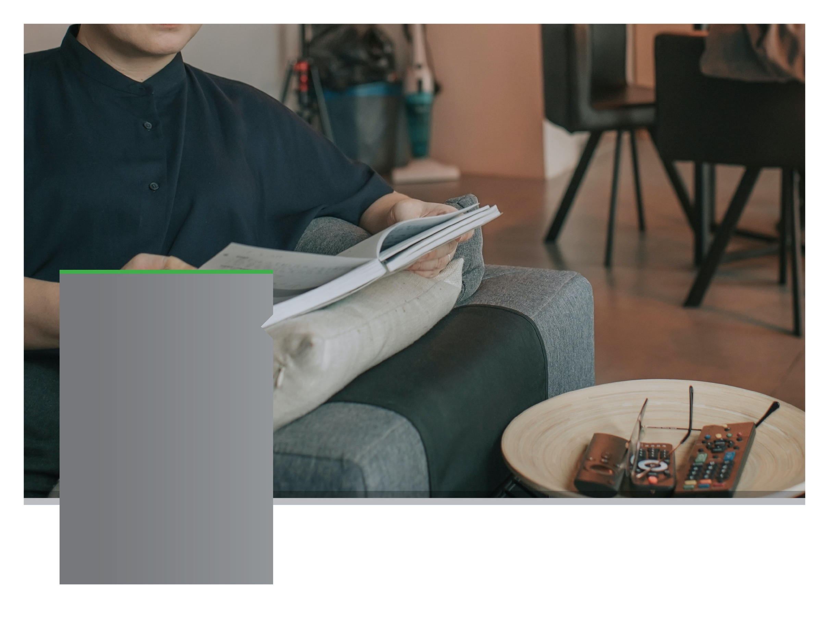

**YOUR EMPLOYEE**

**ASSISTANCE PROGRAM**



Switch on to Being More Present

ONLINE SEMINAR

Reducing technology overload

Discover the key to being more present and actively taking the time to digitally disconnect to spend quality time with those around you.

**SEPTEMBER 2021**

Visit your home page starting September 21st

WEBSITE: [www.mygroup.com](http://www.mygroup.com) > My Portal Login > Work-Life

USERNAME: organization specific

PASSWORD: password

LET US HELP

Always Available | Free | Confidential

**SEPTEMBER 2021**