Wellbeing Videos
Student Assistance Program

New Content – Wellbeing Videos

Wellbeing Videos are a new benefit available through your SAP. These videos range in topics from mental, physical, and practical wellbeing. In these videos, local hosts explain or showcase their science-backed practices, techniques, and rituals, producing modern content that is designed to be quick, engaging, and effective. You can find these videos using the login information below.
Bills, health care, retirement savings, and taxes all take enough out of our paychecks already. What about everything else? To help you stretch your dollar, you and your family have access to a free online benefit Perks at Work available through the Savings Center. Earn WOW shopping points to use toward future purchases in addition to discounts. Training programs are also available through the COA – Community Online Academy.
Register for free on your employee support website.



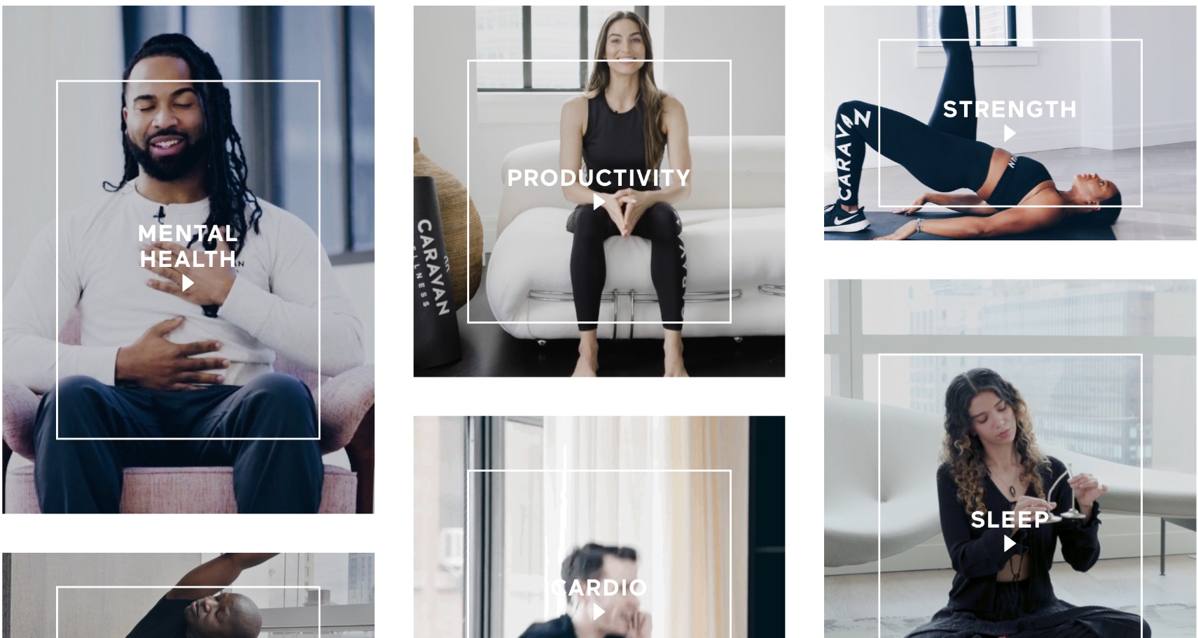

}

TOLL-FREE: 800-633-3353
WEBSITE: www.mygroup.com > My Portal Login > Work-Life
Username: organization specific • Password: guest


