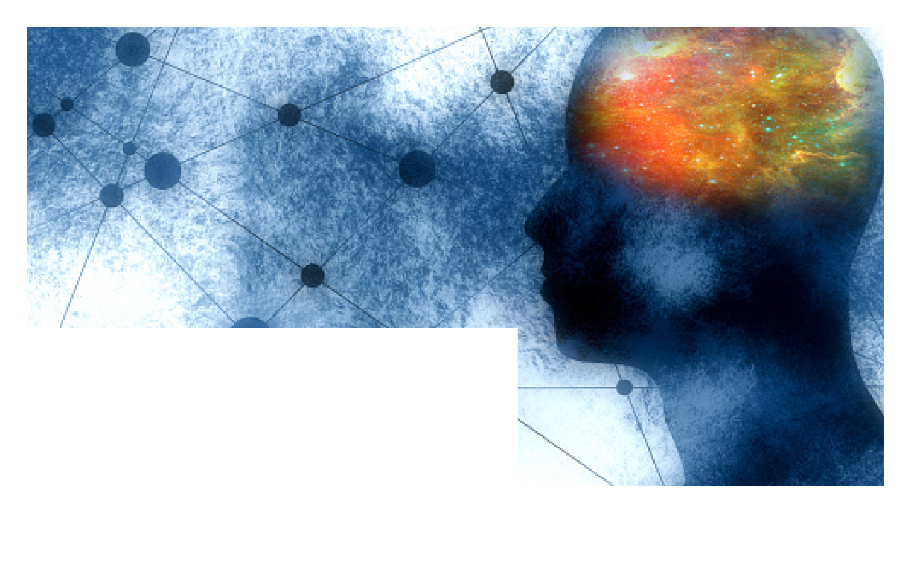



**MENTAL HEALTH DAY**

**World**

October 10th is

**YOUR EMPLOYEE   
ASSISTANCE PROGRAM**

Anytime, any day, you have free, confidential access to professional consultants and online resources to help you be your best. Just call or log on to get started.

TOLL-FREE:   
**800-633-3353**

WEBSITE:  
**www.mygroup.com**

USERNAME:   
**Organization specific**

PASSWORD:   
**guest**



How are you feeling? Small things can make a big difference in how you feel, and how you cope with life’s ups and downs.

Mental health includes your emotional, psychological, and social wellbeing. It affects how you think, feel, and act. It also helps determine how you handle stress, relate to others, and make choices. Mental health is important at every stage of life, from childhood and adolescence through adulthood.

**Positive mental health allows you to**

- Realize your full potential

- Cope with the stresses of life

- Work productively

- Make meaningful contributions to your community

Make sure you take time to place enough importance on your mental health. Be mindful, explore your mind-body connection, and be aware of your physical wellbeing needs. Here are some things to think about while keeping a holistic perspective to mental health.

- Accept yourself

- Keep active

- Do things with others

- Eat healthily

- Make time for family and friends

- Take time out

- Sleep well

- Talk about how you feel

- Do something creative

- Get professional help if you need it